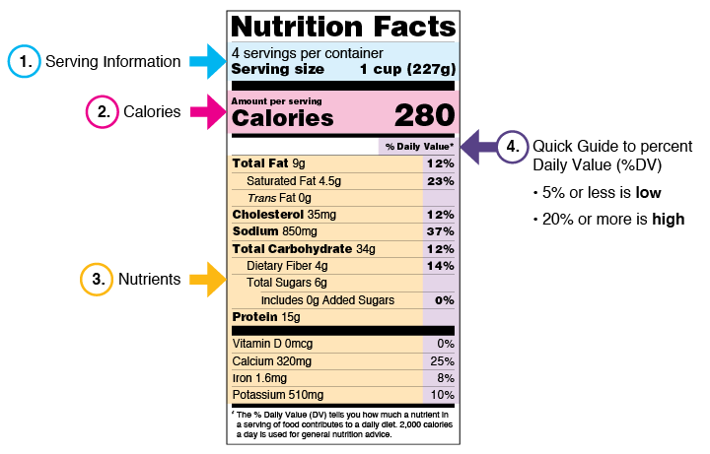

2e) Discuss the following food label terms: calorie, fat, saturated fat, trans fat, cholesterol, sodium, carbohydrate, dietary fiber, sugar, protein. Explain how to calculate total carbohydrates and nutritional values for two servings, based on the serving size specified on the label.

* **Calorie:** A calorie is**a unit measuring how much energy an amount of food will provide to your body.**Almost all food contains calories. On a food label, the calories listed indicate how many calories you’ll be eating in one serving. Scientifically speaking, a calorie is the energy needed to raise the temperature of 1 kilogram of water by 1°C.
* **Fat:** Lipids/fats are one of the three basic macronutrients (Fats, carbs, and proteins) and play a necessary role in maintaining a healthy diet. However, consuming fats too often can lead to obesity along with other health problems. Eat fewer fatty foods, as **lipids contain more calories per gram than either proteins or carbs.** We’ll be talking more about fats in just a bit.
* **Carbohydrate:**Carbohydrates (also called carbs) are also one of your body’s three essential macronutrients, and can be found in sugars, starches, and fibers. Most people consume carbs as their main source of fuel. Common sources of carbohydrates include breads, vegetables, grains, and whole fruits.   
    
  However, not all carbs are created equal.**There are two types of carbohydrates: refined (also called simple) carbs and whole (also called complex) carbs.** Whole carbs are good for your body and include unprocessed foods like vegetables, brown rice, and whole grains.   
    
  On the other hand, refined carbs are bad for you. Filled with added sugars and missing essential vitamins, bad carbs are often cheaper but provide little nutritional value. Examples of bad carbs include sodas, pastries, ice cream, as well as most junk foods you’d find in the supermarket.
* **Protein:**Protein is the third and final macronutrient that makes up a balanced diet. Your body uses proteins to repair body tissue and build muscle. Your proteins also release enzymes, hormones, and other chemicals that support a healthy lifestyle.  
    
  By eating foods that are rich in proteins, you’ll be able to repair your body and build muscle after a long day of Scouting activities. The highest-quality proteins come from lean food sources such as fish, poultry, beans, and plants.  
    
  Consuming processed protein sources such as bacon, sausages, and cheap red meats can increase your chances of heart disease. **To choose the best sources of protein, look for foods that are low in fats and high in micronutrients and fiber.**

The next few terms are all about fat.

* **Cholesterol:**  Cholesterol is a fatty substance that produces vitamin D, hormones, and other helpful substances in your body. However, **eating fatty foods can cause high cholesterol which will lead to artery blockages** and other serious medical issues.   
    
  You have two different types of cholesterol: HDL and LDL. This stands for high-density lipoprotein and low-density lipoprotein. What you need to remember is that**HDL is good, while LDL causes artery blockages and is bad.**  
    
  Fatty foods like eggs, beans, avocados, and fish are high in HDLs and good sources of fat to consume. However, foods like butter, animal fats, and pastries are high in LDLs, and should be avoided. We’ll be going into more detail on different types of fats.
* **Saturated fat:**Saturated fats are one of the worst types of fats to consume. Overconsumption of saturated fats has been linked to increased cholesterol, higher risks of cancer, and heart disease. Some foods that are high in saturated fat include whole milk and fatty cuts of red meat.
* **Trans fat:** Try to avoid consuming trans fats. Not only do **trans fats increase your LDL cholesterol, they also lower your ‘good’ HDL cholesterol.** This can greatly increase your risk of heart disease.   
    
  Trans fats have become less common after the FDA proposed banning these fats in processed foods. However, be careful of frozen foods, as well as fast foods and french fries, as these have been found to contain trans fats along with other unhealthy fats.
* **Sodium:**Sodium is mainly found in salt and is a necessary part of your daily diet. However, **consuming too much sodium can lead to high blood pressure.** Try to consume your dietary recommendation of sodium and avoid processed foods as they often contain more salts and sugars.
* **Dietary Fiber:** Fiber helps you poooop! 🙂 Just making sure you were still paying attention. But seriously, dietary fiber is an important part of a healthy diet. **By consuming fiber daily, you’ll have regular bowel movements.** This, in turn, will reduce your risk of colon cancer and support healthy cholesterol levels.
* **Sugar:** Don’t hate me for saying this, but sugar is really bad for you. Seriously. While sugars can be found naturally in most foods, much of what we eat today also contains large amounts of added sugars.

Which is a better snack, RITZ Crackers or Baby Carrots?

**Common Food Allergies**

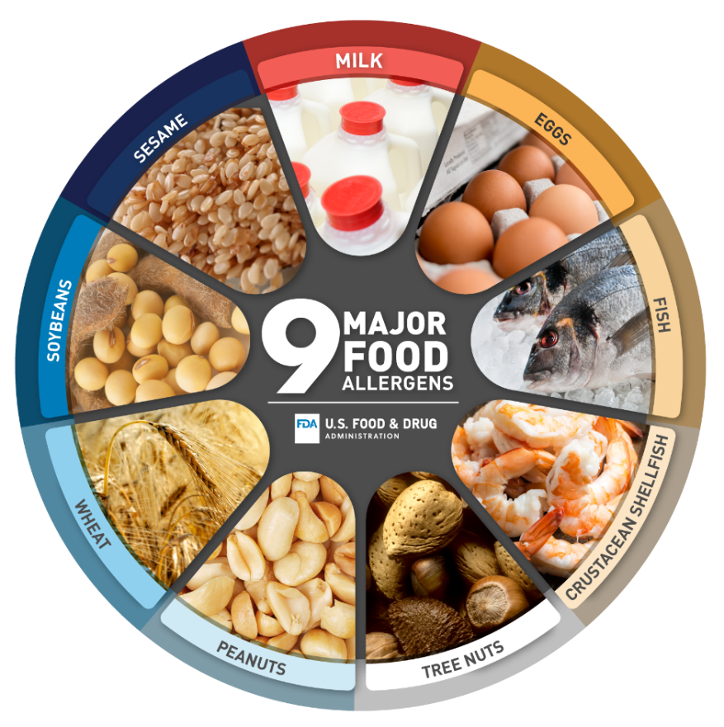

**Example Packaged Food Ingredient Lists**



